COMENIUS PROJECT "ECO PALS"
LESSON "ON BULGARIA WITH THE FIVE SENSES" - AGE 5 -6 YEAR OLDS

- I'm from Bulgaria:
- Bulgaria small but very beautiful country. The people who live there enjoy the sun, sea, trees, birds and flowers. What do you enjoy in England?
- I live and work in the capital of Bulgaria.Sofia is the largest city of Bulgaria. It's name Sofia means wisdom. What is the capital of England?
- I work at a school with 1,000 students.They send you greetings, and in the end, will leave their greetings to you as a souvenir. How many children are there at your school?

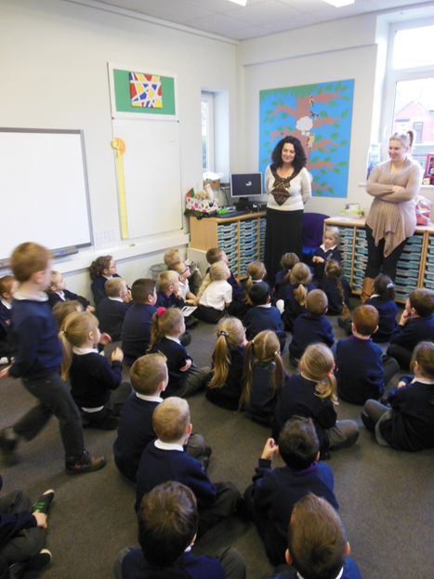

- I have brought a box where I hid the most interesting things in my
country.
- The capital of Bulgaria is situated near Vitosha mountain.Many years
ago the mountain was a small volcano. What do you know about volcanoes?
- Every time it erupted its lava, the volcano Vitosha threw large
stones.Then it became extinct. The Earth froze. But the sun rays thawed the "hat" of the volcano and huge pieces of ice descended to the plain. The gravity of the stones rounded them and an enormous stone river was formed. I've brought a little pebble for you from that river. Feel it, pass it to your friend next to you and say what you feel.

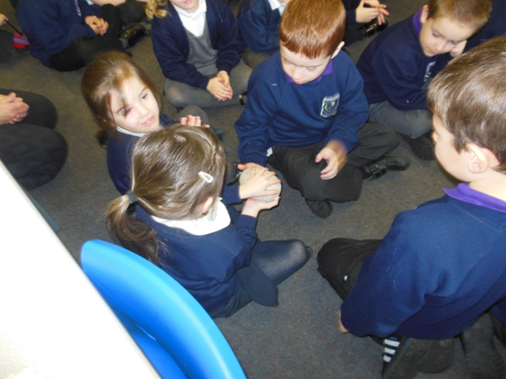

- Today Vitosha Mountain is a favorite place for walk for the citizens of
Sofia. A part from the stone rivers, it has a lot of meadows with wild flowers and aromatic herbs scattered all around them. Bulgarians gathered herbs to make tea on cold winter days. I have brought you thyme and lime tea bags. What is the difference between grass and a tree? Thyme herb and lime is collected from trees. When these packets are brewed with hot water, you will feel the scent of Bulgarian herbs.

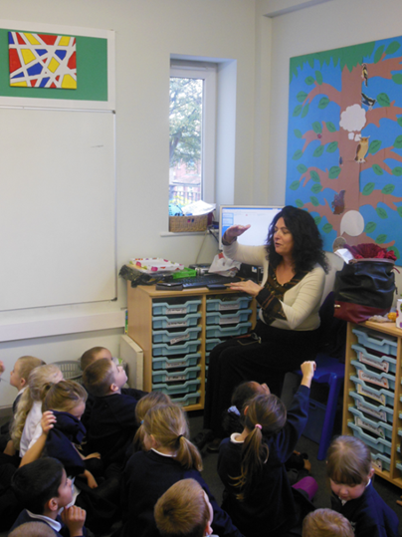

- Bulgarians never sit at a table without bread. What do they make the
bread from?
I have brought you one of these plants, because I know you know it.

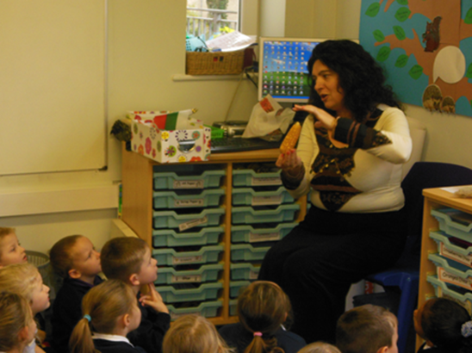

- Bulgarians never sit at a table without salt.What is the taste of the salt?
What is the taste of the salt? What is its smell?
- Bulgarians add the smell of aromatic herbs that grow in abundance to
the salt. That is why the salt, which I have brought you has a typical, Bulgarian flavor. The colors in it are the colors of the aromatic herbs.

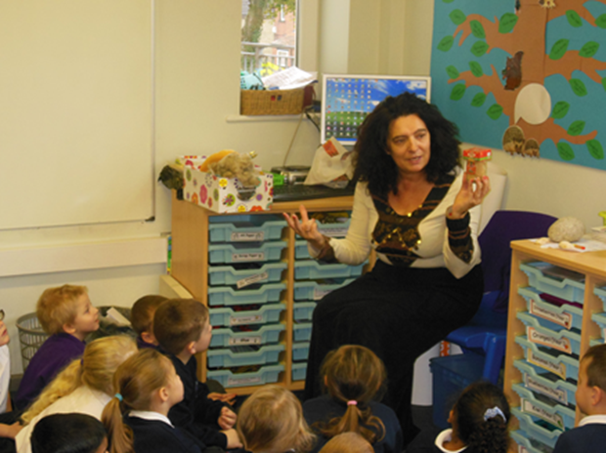

- The extract salt from the sea. The Sea in ​​Bulgaria is beautiful. Who
among you have ever been on holiday at the Bulgarian seaside? What else have you see there? I have brought you some shells. Feel them and give them to you neighbor and say what felt?

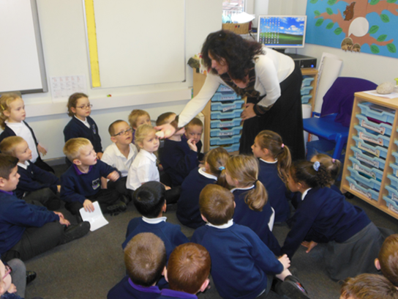

- What animals do people grow in your town and its vicinity? Why
do people keep sheep?
We keep many sheep in Bulgaria. That wool is from those sheep. Feel it, give it to your neighbour and say what you feel? Bulgarians color it in order to make beautiful clothes from it .
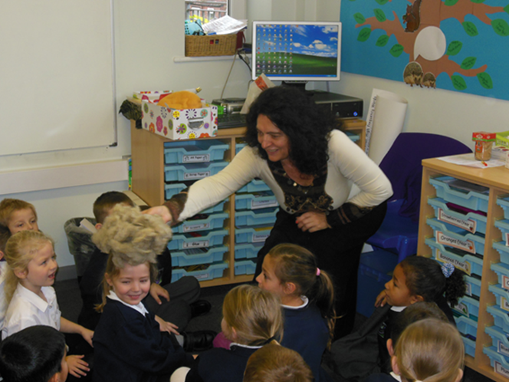

- They call Bulgaria the country of roses. What do you know about roses? I have brought you an aroma of Bulgar roses. In this little vial they gathered the aroma of our Rose Valley. What do you feel?

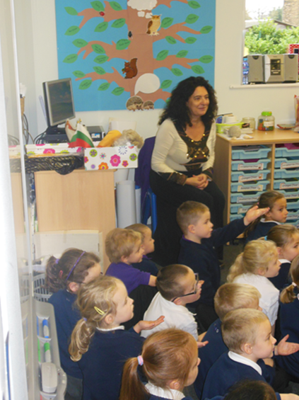

- - Have you remembered the name of my home country?
What have you felt in my story about Bulgaria?

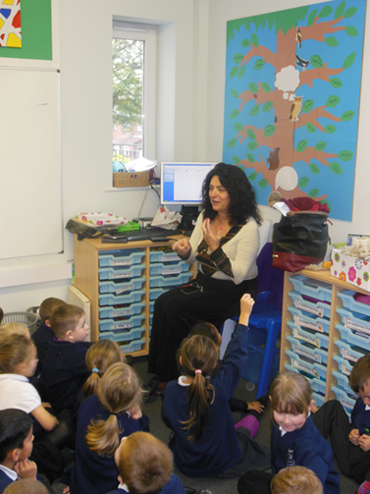

- Now we will present you a story about Bulgaria made my pupils, and you watch it carefully. Whenever you see something you are already familiar with about Bulgaria give me a sign to see it again in a better way.
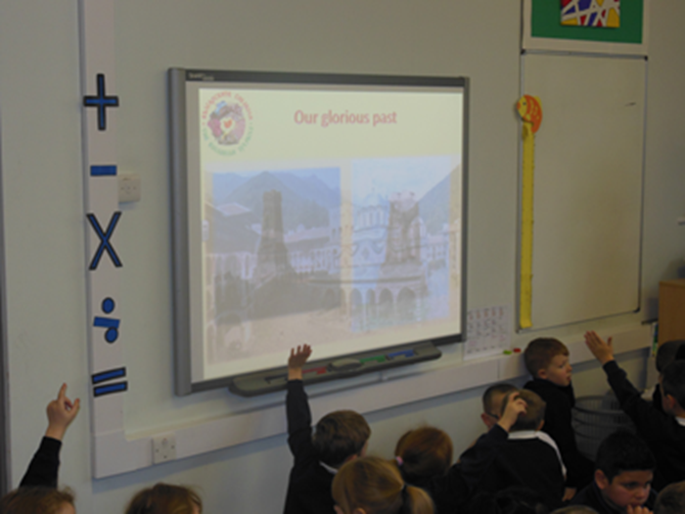

- I'm sure now - Bulgaria is not unknown for you.I hope that you will tell parents about our today's meeting. I expect you at the seaside in the summer ...

The lesson is realized by Mrs Rosittsa Dimova from 137th Secondary School "Angel" within a 40- minute lesson with the help of the teachers from the English school.There were 60 pupils.

