COMENIUS PROJECT "ECO PALS" 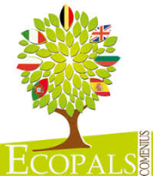
Let’s get to know Bulgaria
(lesson, 10 years old)

- Introduction
Hello, everybody! Nice to meet you. I am Irena Raykova. These are Hristalena Georgieva and Nora Topalova. We come from Bulgaria. We are teachers. Today we are going to help you to get to know Bulgaria.
- Main part of the lesson
I suggest you to start our lesson in Bulgarian. Let’s greet each other! May this page be the first page of your Bulgarian dictionary:

Hello! – Здравей!(Zdravej!)
Nice to meet you! – Приятно ми е да се запознаем!(Priyatno mi e da se zapoznaem!)
What’s your name? – Как се казваш?(Kak se kazvash?)
My name is…- Казвам се…(Kazvam se…)
How are you? – Как си?(Kak si?)
I’m fine, thank you! - Добре съм, благодаря.(Dobre sum, blagodarya.)
Goodbye! – Довиждане!(Dovizhdane!)

“Hello!” - “Здравей!“ Can you teach us how to say “Hello!” in Spanish? When we meet someone for the first time, we say: “Приятно ми е да се запознаем!“(„Nice to meet you!”) Let’s practice! You can ask “What’s your name?” - „Как се казваш?“ and answer “My name is…” - „Казвам се…“ Teachers greet students individually and encourage them to speak Bulgarian.
Hristalena and Nora will hand out small maps of Bulgaria.
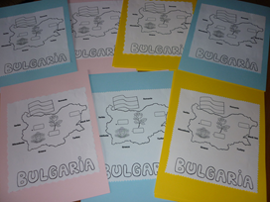
Do you know where our country is located? (It is located in south-eastern Europe on the Balkan Peninsula. The region has its name from the Balkan Mountains that stretch from the east of Bulgaria to the very east of Serbia. ). Look at the map! Can you name our neighbors? (Bulgaria is bordered by Romania to the north, Serbia and Macedonia to the west, Greece and Turkey to the south, and the Black Sea to the east.)
Have you ever been to Bulgaria? Where have you been? Let’s watch the video and find out what you can see in Bulgaria(the biggest cities, places of interest, nature).
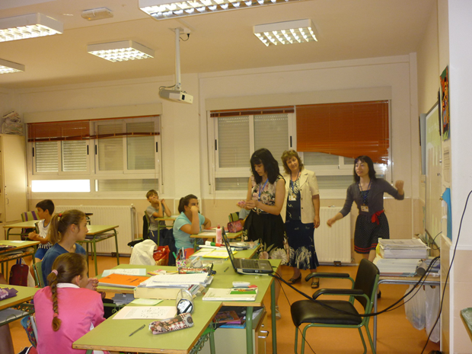
Would you like to visit our country? Imagine you are going to visit Bulgaria and meet Bulgarian eco pals. I am wondering whether you know how far it is from Valencia to Sofia? Guess!
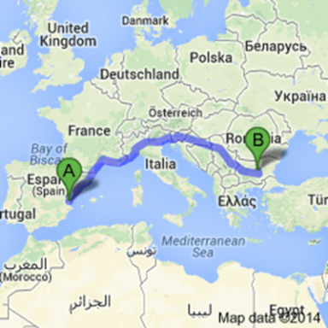
Actually it is 1251 miles or 2012.86 KM. So if you want to visit Bulgaria, your flying time will be 5 hours and finally you will land at the airport of our capital. What is the capital of Bulgaria? Yes, it is Sofia. Sofia is the city where Nora, Hristalena, I and Bulgarian eco pals live. I suggest you to find the biggest dot on your map and label it Sofia(so you will exactly know where the plane will land).
During your journey in Bulgaria, you will get hungry, of course. Here are some recipes of traditional Bulgarian dishes that you can try first at home and then in Bulgaria.
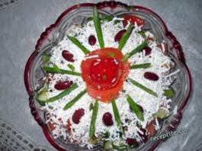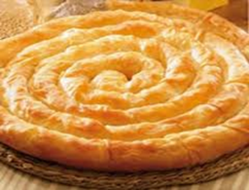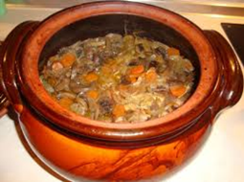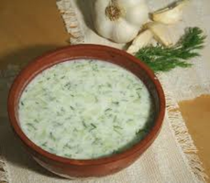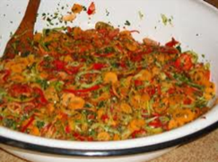
Shopska salad Banitsa Kavarma Tarator Mish- Mash
Now have a look at the Black Sea and find the dot that is near the eastern border of our country. If you want to go to a seaside resort in Bulgaria, you can go to Varna. Varna is the largest city and a seaside resort on the Bulgarian Black Sea Coast and the third largest city in Bulgaria. Find the smallest dot on the map – it is Plovdiv, the second-largest city in Bulgaria after the capital Sofia.
Here is the Bulgarian flag. As you can see the colours are missing. Do you know the colours of our flag? Colour the flag white, green and red. Here are some Bulgarian flags, made by the students from my class especially for you. Hristalena and Nora will hand them out.
Please, look at the flower in the middle of your map. Do you know its name? Yes, it is a rose. We say “Roza” in Bulgarian. Do you have any idea why the rose is on the map of Bulgaria? Actually Bulgaria is famous for its rose oil. The Rose Valley (also called The Valley of Roses) is a region in central Bulgaria, where the famed Bulgarian oil-bearing rose grows.
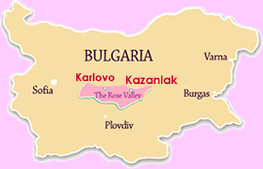
If you want to come into contact with one of the miracles of Bulgaria, you have to go through the Valley of Roses during the rose-picking season from May 15th to June 15th so that you can feel the scent, which is spread in the air by the morning dew over the rose gardens near Kazanlak. We took some natural Bulgarian rose water and some rose perfume essence to make you feel the fragrance of the Bulgarian roses. Do you feel the smell of the roses?
Let’s go back to the maps on your desks and colour the rose – one of the symbols of our country. I hope that whenever you think about our country, you will remember at least three things about Bulgaria.
As I told you we live in Sofia and work at 137th SOU “Angel Kanchev”. Each student from the 6th grade has written a personal letter for you. Mrs Nora Topalova is their class teacher. Our students are thrilling and waiting for your answers.
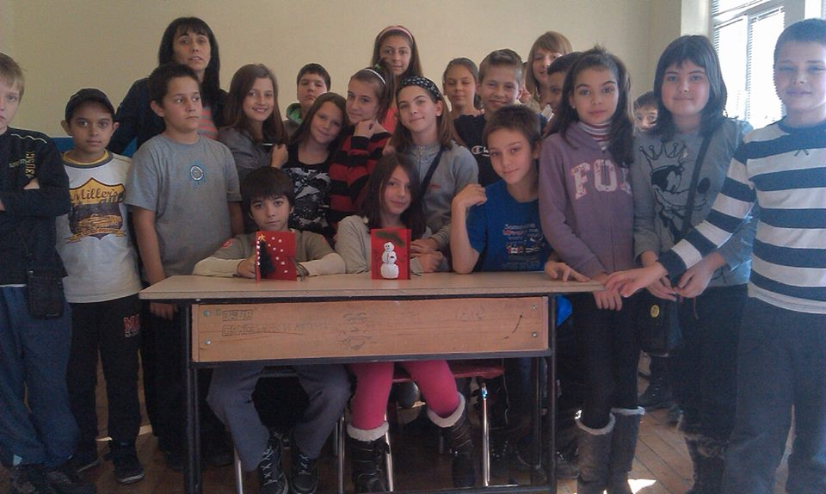
Hristalena and Nora will hand out white pages where you can write and draw something to Bulgarian eco pals within ten minutes. When you are ready, you can give the letters to Nora and Hristalena.
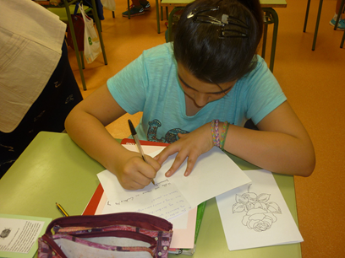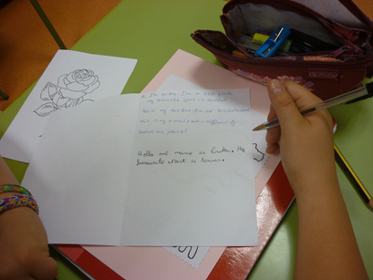

3. Conclusion
Although we are having a good time here our lesson goes to its end. Does everyone can:
- Say some greetings in Bulgarian.
- Say where Bulgaria is located.
- Recognize the Bulgarian Coat of Arms and the Bulgarian flag.
- Name the capital of Bulgaria.
- Name the biggest cities in Bulgaria.
- Recognize the fragrant smell of our roses.
- Choose what to eat.
I am absolutely sure that when you come in Bulgaria, you will have a great time, because you can speak a little Bulgarian and you know where to go and what to visit, don’t you?
Thank you for being so active and friendly!
Goodbye, eco pals!(Довиждане!) We hope to see you in Bulgaria!
137 SOU “Angel Kanchev”, Bulgaria
Teachers: Irena Raykova
Hristalena Georgieva
Nora Tоpalova

